**AI AGENT FOR CHRONIC DISEASE MONITORING USING IBM CLOUD**

**INTERNSHIP PROJECT REPORT**

**AICTE: IBM SKILLS BUILD**

**NAME: BHAVADHARINI G**

**ROLL NO: 24MDS005**

**DEGREE/BRANCH: M. TECH IN DATA SCIENCE**

**DEPARTMENT: INFROMATION TECHNOLOGY**

**COLLEGE: KUMARAGURU COLLEGE OF TECHNOLOGY**

**ORGANIZATION: EDUNET FOUNDATIONS**

**SUPERVISOR: ELURI NARENDRA**

**1. Introduction**

Chronic diseases such as diabetes, hypertension, and heart disease require continuous management to prevent complications and hospitalizations. Traditional healthcare approaches often rely on periodic visits and self-reported symptoms, which can result in delayed interventions and suboptimal patient outcomes. Recent advances in technology, particularly artificial intelligence (AI), have transformed this landscape by enabling real-time monitoring, predictive analytics, and personalized support for both patients and healthcare providers. An AI agent for chronic disease monitoring leverages data from wearables, electronic health records, and patient inputs to provide continuous, objective health oversight. This allows for early detection of disease deterioration, timely medication reminders, and proactive lifestyle recommendations tailored to each individual. By utilizing platforms like IBM Cloud Lite and IBM Granity, such solutions offer scalable, secure, and intelligent analytics capable of integrating large streams of real-time patient data. Machine-Fault-Diagnosis-Agent-Using-Agentic-AI-and-IBM-Cloud.docxUltimately, AI-powered agents bridge the gap between patients and their providers, reduce unnecessary hospital visits, and empower individuals to take an active role in managing their chronic health conditions.

**2. Problem Statement and Objectives**

**2.1 Problem Statement**

Chronic diseases such as diabetes, hypertension, and heart conditions require continuous and proactive management to prevent complications and reduce hospital visits. Existing methods largely rely on infrequent clinical visits and patient self-reporting, which delay early detection of deteriorations in health. The challenge is to develop an AI-powered agent that continuously monitors real-time health data from wearables, medical records, and patient inputs. This agent must use predictive analytics to detect early warning signs, provide personalized insights, medication reminders, and lifestyle recommendations. It should enable better adherence to treatment plans, support timely interventions, and bridge the communication gap between patients and healthcare providers. Deploying this solution using IBM Cloud Lite services and IBM Granity presents opportunities for scalable, secure, and intelligent chronic disease management but also requires addressing data integration, real-time processing, privacy, and explainability challenges.

**2.2 Project Objectives**

The project aims to develop an AI-powered agent that continuously monitors chronic diseases such as diabetes, hypertension, and heart conditions by integrating real-time health data from wearable devices, medical records, and patient inputs. Leveraging IBM Cloud Lite services and IBM Granity, the system will provide scalable, secure, and intelligent cloud-based analytics capable of detecting early warning signs through predictive models. It will offer personalized medication reminders, lifestyle recommendations, and health insights to enhance patient adherence and proactive disease management. The agent will enable seamless communication between patients and healthcare providers via interactive dashboards and real-time alerts, addressing data privacy, integration challenges, and ensuring explainability of AI-driven decisions. Ultimately, the solution strives to improve patient outcomes, reduce hospital visits, and empower individuals to manage their chronic health conditions effectively.

**3. Literature Review and Theoretical Background**

Artificial intelligence (AI) has emerged as a transformative technology in chronic disease management, offering advanced capabilities in continuous monitoring, predictive analytics, and personalized care. Recent studies demonstrate that AI-powered systems significantly improve diagnostic accuracy and early detection of conditions such as diabetes, hypertension, and cardiovascular diseases compared to traditional clinical approaches. Machine learning algorithms, including deep learning models, support risk stratification, anomaly detection, and treatment personalization by analyzing large-scale heterogeneous data from wearables, electronic health records, and patient-reported outcomes. The integration of IoT devices with AI models facilitates real-time health surveillance, enabling timely interventions and reducing hospitalizations. Additionally, AI-based conversational agents enhance patient engagement by providing medication reminders, lifestyle recommendations, and easy access to medical information. Theoretical frameworks such as predictive analytics underpin these systems, leveraging historical and current data to forecast disease progression and identify critical risk factors. Despite these advances, challenges related to data privacy, model explainability, and interoperability remain. Employing IBM Cloud Lite and IBM Granity in this context promises scalable, secure deployment of AI models capable of addressing these challenges while delivering impactful chronic disease monitoring and management solutions. This review highlights the pivotal role of AI in shifting healthcare from reactive to proactive approaches, improving patient outcomes through data-driven decision support.

**4. System Architecture and Implementation**

**4.1 Architecture Overview**

The AI agent for chronic disease monitoring system architecture is designed to provide continuous, real-time health management by integrating multiple advanced technologies within a secure cloud environment. At the core, it collects data from diverse sources, including wearable health devices that track vital signs like blood glucose levels and blood pressure, electronic health records, and patient-reported inputs through mobile apps. This heterogeneous data is securely ingested and stored using IBM Cloud Lite's Object Storage service, ensuring compliance with healthcare data privacy standards. The analytical engine leverages IBM Granity AI to process and analyze the aggregated health data through predictive analytics and machine learning models, identifying early warning signs of disease progression or acute events. The agentic AI framework built on IBM Watsonx employs advanced reasoning workflows like LangGraph and ReAct to generate personalized medication reminders, lifestyle suggestions, and real-time alerts for patients and healthcare providers. The system’s user interface delivers these insights via interactive dashboards and mobile notifications, enabling proactive disease management and enhanced patient care. The modular architecture supports scalability and future integration of additional chronic conditions and new sensor modalities while maintaining robust security, data privacy, and seamless interoperability with healthcare systems. This comprehensive framework exemplifies the use of AI and cloud technologies to transform chronic disease care from reactive to predictive and personalized management.

**4.2 Platform and Tools**

The project leverages IBM Cloud Lite services as the primary cloud platform owing to its scalability, security, and free-tier access to essential cloud resources. IBM Cloud Object Storage is used for secure, HIPAA-compliant data storage of patient health data sourced from wearable devices and electronic health records. The AI modeling and intelligence layer is built using IBM Granity, which provides advanced AI frameworks, including LangGraph for knowledge representation and ReAct for reasoning architectures optimized for healthcare applications. IBM Watsonx.ai serves as the agentic AI development environment, allowing the creation, training, and deployment of conversational and analytic agents capable of real-time interactions and personalized guidance. Additional tools such as API keys, cloud databases, and diagnostic tool integrations facilitate smooth data flow, authentication, and interoperability. Overall, the chosen platforms and tools provide a robust foundation to build an end-to-end, real-time chronic disease monitoring solution with enhanced analytical capabilities and patient engagement features.

**5. Sample Use Cases and Query Examples**

The agent supports typical health monitoring and patient support questions such as:

* “Are there any early signs of complications in my diabetes readings?”
* “What lifestyle changes can help improve my heart condition based on current data?”
* “What does my recent blood pressure trend indicate about my hypertension management?”

**Example answer for early diabetes complications:**

High blood sugar readings, blurry vision, poor night vision, and high levels of ketones in urine or blood may indicate potential complications. It is recommended to consult a healthcare provider if such symptoms persist for timely intervention and management.

**Example answer for heart condition lifestyle improvement:**

Dietary changes focusing on low fat and salt, regular physical activity, and managing stress through meditation are recommended to improve heart health. Quitting smoking and monitoring blood pressure and cholesterol levels also contribute to better outcomes.

**Example answer for hypertension management:**

Consistently maintaining healthy blood pressure trends suggests effective control of hypertension. Continued lifestyle modifications, such as reduced sodium intake and regular exercise, help maintain optimal levels, but regular consultation with a healthcare provider is essential for ongoing management.

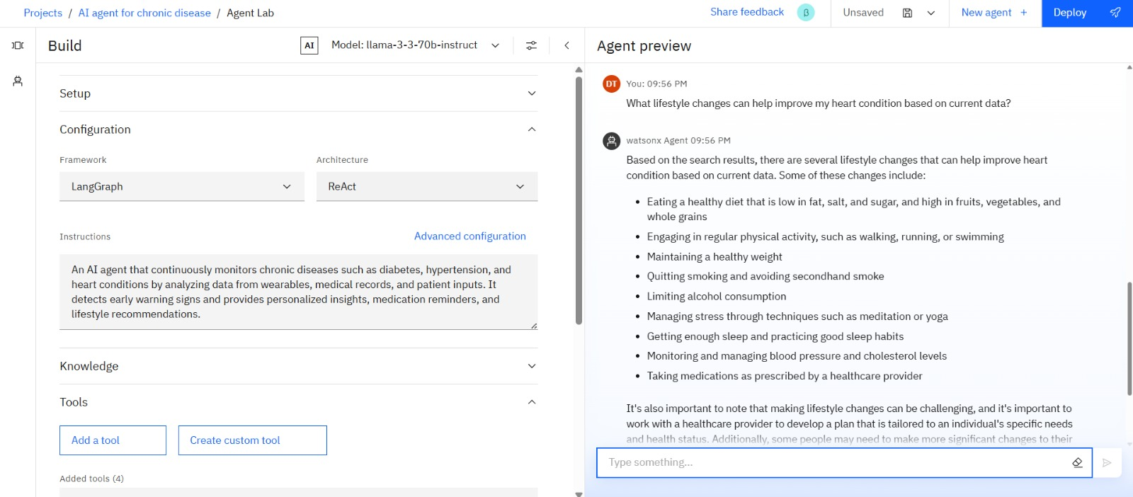

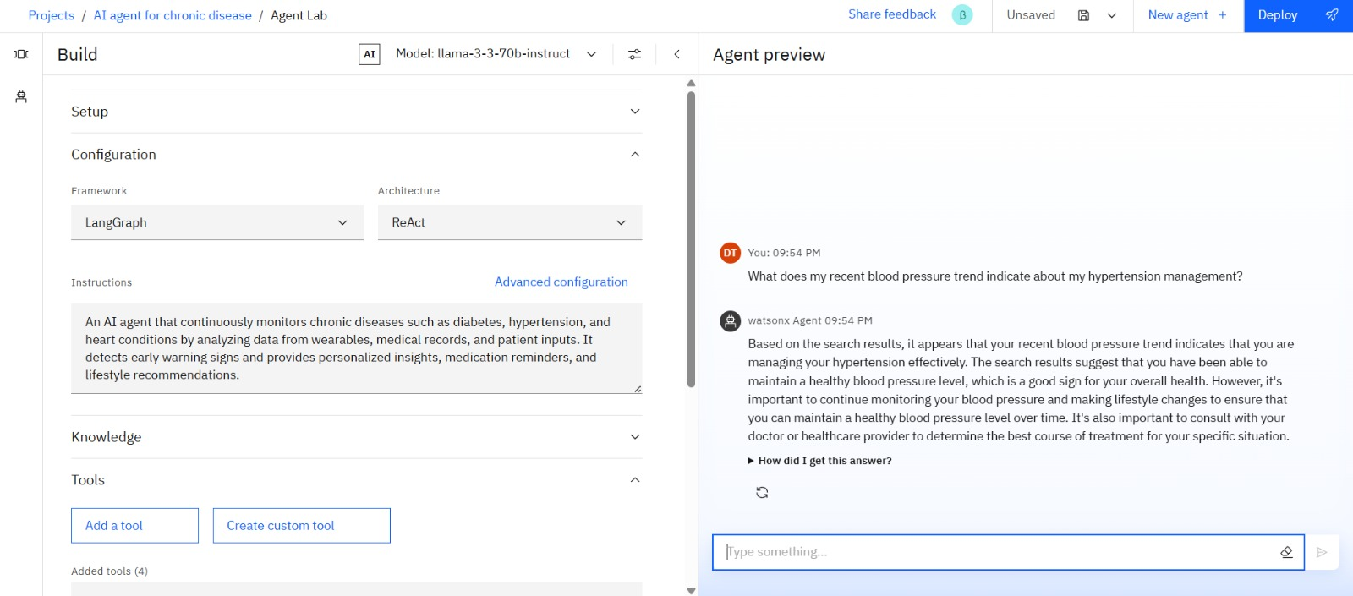

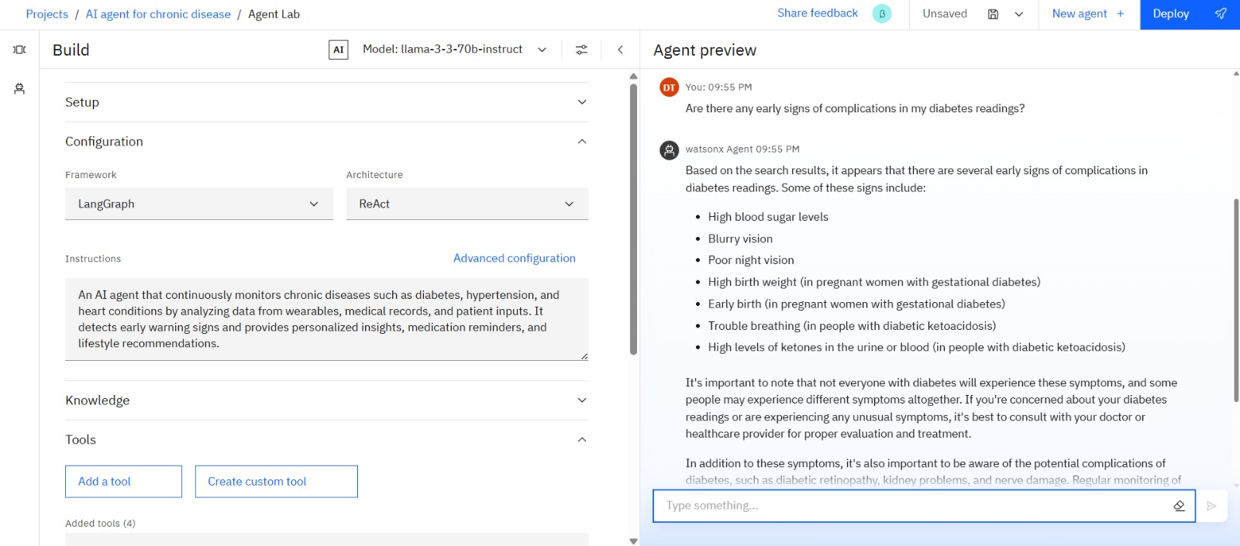

**6. Challenges Faced and Solutions**

The project utilizes a robust platform combining IBM Cloud Lite services and advanced AI tools to deliver an efficient chronic disease monitoring solution. IBM Cloud Lite provides scalable, secure, and cost-effective cloud infrastructure with essential storage and computational capabilities, allowing seamless ingestion and management of vast amounts of health data from multiple sources. IBM Granity powers the AI processing module, leveraging sophisticated machine learning and reasoning frameworks such as LangGraph and ReAct to analyze data, generate early warning alerts, and offer personalized recommendations. Watsonx.ai forms the interface and agentic AI environment, enabling conversational AI interactions with patients and clinicians to enhance engagement and care adherence. Integration with wearable devices, electronic health records, and patient-facing mobile applications ensures comprehensive data coverage. Together, these platforms and tools create a flexible, end-to-end ecosystem capable of addressing the challenges of real-time chronic disease management while maintaining privacy, reliability, and extensibility for future enhancements.

**7. Impact and Future Work**

The AI agent for chronic disease monitoring holds significant potential to transform healthcare delivery by enabling continuous, real-time patient monitoring and personalized care. Its impact includes improved early detection of disease complications, enhanced patient adherence to treatment plans through timely reminders and lifestyle recommendations, and reduced hospital admissions by facilitating proactive interventions. By analyzing diverse data streams such as wearables and medical records, the agent supports healthcare providers in making more informed, data-driven decisions, increasing care efficiency and patient safety. The system also democratizes access to care by allowing remote monitoring and minimizing the need for frequent hospital visits, which is especially valuable for patients in underserved or rural areas. Future work involves expanding the agent’s capabilities to support a broader range of chronic conditions, integrating advanced predictive analytics to estimate disease progression, incorporating multilingual and voice-based interactions, and further improving AI explainability and data privacy. These advancements will bolster the AI agent’s role as a comprehensive tool for proactive chronic disease management, ultimately improving patient quality of life and reducing healthcare costs.

**8. Conclusion**

In conclusion, the AI agent for chronic disease monitoring represents a significant advancement in healthcare delivery by enabling continuous, personalized, and proactive management of chronic conditions such as diabetes, hypertension, and heart diseases. By integrating real-time data from wearables, medical records, and patient inputs within a secure IBM Cloud Lite environment, and applying sophisticated AI analytics through IBM Granity and Watsonx.ai, the system enhances early detection of health deterioration, supports medication adherence, and offers tailored lifestyle recommendations. This intelligent agent bridges the gap between patients and healthcare providers, reduces hospital visits, and empowers patients to take an active role in their health management. The future of chronic disease care lies in expanding such AI-powered solutions, improving explainability and privacy, and integrating them seamlessly into clinical workflows to deliver better outcomes and more efficient healthcare systems globally.

**9. References**

1. **IBM Official Cloud and Granite AI Documentation:**IBM Cloud: <https://www.ibm.com/cloud>  
   IBM Granite AI overview and technical docs: <https://www.ibm.com/granite>  
   Granite AI detailed documentation: <https://www.ibm.com/granite/docs/models/granite/>
2. **Scholarly Articles on AI in Chronic Disease Monitoring and Healthcare:**Artificial Intelligence in Chronic Disease Management (PMC): <https://pmc.ncbi.nlm.nih.gov/articles/PMC11747633/>  
   Advanced Applications in Chronic Disease Monitoring Using AI (Frontiers): <https://www.frontiersin.org/journals/publichealth/articles/10.3389/fpubh.2025.1510456/full>  
   AI Wearables for Real-Time Chronic Disease Monitoring (XenonStack): <https://www.xenonstack.com/blog/ai-wearables-monitoring-chronic-diseases>Impact of Artificial Intelligence on Chronic Disease Management (Mahalo Health): <https://www.mahalo.health/insights/the-impact-of-artificial-intelligence-on-chronic-disease-management-current-applications-and-future-direction>
3. **Books and Online Resources on AI and Predictive Analytics in Healthcare:**AI Predictive Analytics in Healthcare: Role & Benefits (TechMagic): <https://www.techmagic.co/blog/ai-predictive-analytics-in-healthcare>  
   Artificial Intelligence Applications for Chronic Condition Self-Management (JMIR): <https://www.jmir.org/2025/1/e59632/>